**Meal Budget Planner App Market Research**

**User Group Profile**

* Demographics
  + Age & Lifestyle: Primarily 18-24 year old undergraduate students living on or near campus with semi-independent financial habits
  + Cultural & Economic Diversity: Mix of domestic and international students, many navigating meals plans, scholarships, or parental allowances
  + Digital Behavior: Mobile-first, app-reliant users who expect instant access, intuitive UX, and real-time updates across all campus services
* Pain Points
  + Budget Blind Spots: Students often lose track of dining dollar balances, leading to either premature depletion and/or end-of-semester surplus
  + Fragmented Spending Visibility: Transactions across dining halls, vending machines, and campus cafes lack centralized tracking, causing confusion
  + Financial Anxiety: Many students feel stress or guilt around food spending, especially when juggling limited funds with unpredictable schedules
* Daily Habits HERE.
  + On-the-go eating: Most consume 2-3 meals on campus, often squeezed between classes, study sessions, or extracurriculars
  + Constant Mobile Checking: Phones are checked dozens of times daily for class updates, mobile payments, food orders, and social coordination
  + Food as a Social Glue: Dining is a key social ritual- students bond over coffee runs, late-night snacks, and spontaneous meetups at campus eateries

**Market Size and Opportunity**

| Market Level | Estimate (annual USD) |
| --- | --- |
| TAM- All US undergrads with meal plans | 19.3M undergrads x 40% x $5,656 = $43,664,320,000 (~$43.7B) |
| SAM- Students at 4-year institutions likely on meal plans | 11.3M 4-year students x 60% x $5,656 = $38,347,680,000 (~$38.3B) |
| SOM- realistic near-term capture (5% of SAM) | $1,917,384,000 (~$1.92B) |

As of 2025, there are approximately 19.3 million undergraduate students in the US, with about 40% enrolled in meal plans, based on recent studies showing that 98% of first-year resident students are required to purchase one. The average annual cost of a college meal plan is $5,656. This yields a Total Addressable Market (TAM) of roughly $43.7 billion. Narrowing to students at 4-year institutions, where meal plan participation is higher (~60%), the Serviceable Available Market (SAM) is estimated at $38.3 billion. Assuming a conservative 5% market penetration in the near term, the Serviceable Obtainable Market (SOM) would be $1.92 billion annually.

**Competitor Analysis**

| **App** | **Features** | **Strengths** | **Weaknesses** | **Customer Reviews** |
| --- | --- | --- | --- | --- |
| **CampusDish** | Interactive menus with allergen and dietary filters  Daily meal schedules  Nutritional info  Feedback tools  Campus dining news and events | Comprehensive dining info  User-friendly interface  Promotes healthy eating habits | Limited focus on budgeting or spending tracking  Low user ratings (2.7/5 on App Store) | Users appreciate the convenience but desire more features like spending tracking and budgeting tools |
| **Transact eAccounts** | View account balances  Add funds to account  Track recent transactions  Add ID card to mobile wallet  Multi-factor authentication | Centralized campus commerce platform  Supports various campus services beyond dining | Limited dining-specific features  Requires campus participation  UI can be complex | Users find it useful for managing campus services but feel it lacks dining-specific functionalities |
| **Grubhub Campus** | Mobile ordering but campus dining  Integration with campus meal plans  Real-time order tracking  Customizable payment options | Convenient for ordering food  Integration with campus meal plans | Additional fees on orders  Limited to participating campuses  Not focused on budgeting or spending tracking | Students appreciate the convenience but are concerned about additional fees and limited campus participation |

Potential features for app:

* Real-time budget tracking
* Comprehensive campus integration
* Intuitive UI

**Unique Value Proposition**

Take full advantage of your campus dining dollars with [app name] , the all-in-one app that tracks spending, alerts you before you run low, and helps you plan every meal with ease. Designed for busy college students [app name] makes budgeting simple, prevents wasted funds, and ensures you never miss out on your favorite campus meals.

Key differentiators:

* Dynamic spend forecasting: Predicts when funds will run out based on usage trends, helping students adjust before it’s too late
* Campus-wide integration: Syncs with every dining outlet on campus- from vending machines to pop-up cafes- for total coverage and transparency
* Social and smart features: Lets students share meal plans, split costs, and discover popular dining spots through peer recommendations and real-time feedback

**Visualization**

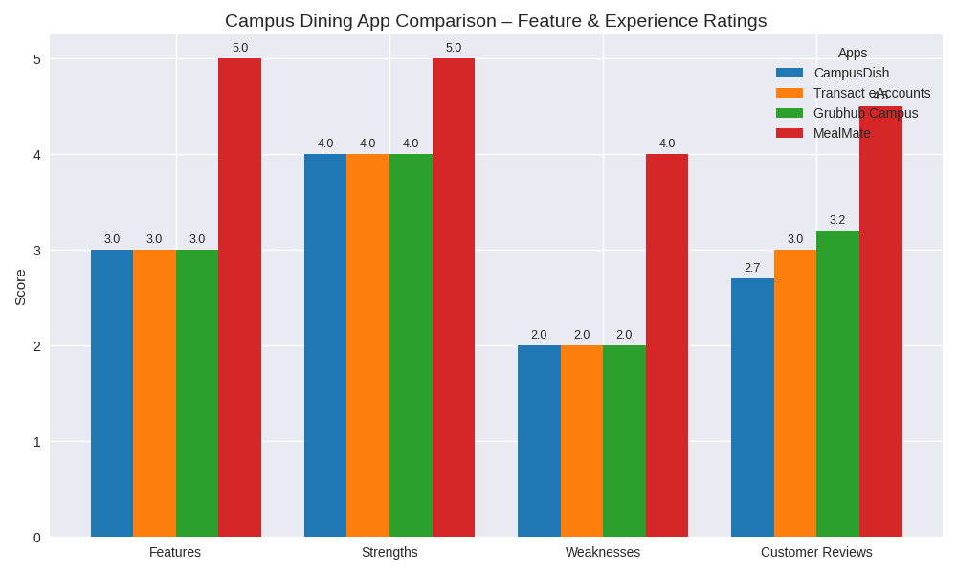

**AI Use Section**

1. I used both ChatGPT and CoPilot
2. You are a market researcher. Analyze the demographics, pain points, and daily habits of potential users for a new dining dollars management app for college students. Present the findings in 3 concise bullet points per category (demographics, pain points, habits).

Act as a business analyst. Estimate the total addressable market (TAM), serviceable available market (SAM), and serviceable obtainable market (SOM) for the dining dollars management app for college students. Use recent statistics where possible. Present the numbers in a short paragraph followed by a 3-row table (TAM, SAM, SOM).

You are a competitive intelligence expert. Compare 2–3 apps similar to the dining dollars management app. Create a table with columns for Features, Strengths, Weaknesses, and Customer Reviews. Highlight any gaps that your app could fill.

Pretend you are a startup pitch coach. Write a clear and persuasive unique value proposition (UVP) for dining dollar management app for college students in 2–3 sentences. Then, list 3 bullet points showing how it differentiates from competitors.

You are a data storyteller. Using the information from earlier slides (market size, competitor ratings, or user habits), recommend one chart or graph that best illustrates the opportunity. Provide the chart description in words and outline the key data points that should appear in the visualization.

1. Both ChatGPT and CoPilot list their sources at the end of each response so it is a very simple fact checking process, just looking at those websites and making sure they are reliable.